Calculations allometries

From what I can see in the xls sheets, allometries were calculated by dividing the arm length by the BL. This is not completely correct (would only work of you had a pure correlation Y=1 x X).
Ideally, what you want to do is for each treatment, compare the regressions between the arm length and BL. This is how I’ve done it in previous papers but we had multiple days and many more larvae per treatment. I tried with this dataset and it leads to weird things due to poor data resolution. For example, for the arm labelled AL and single pH:
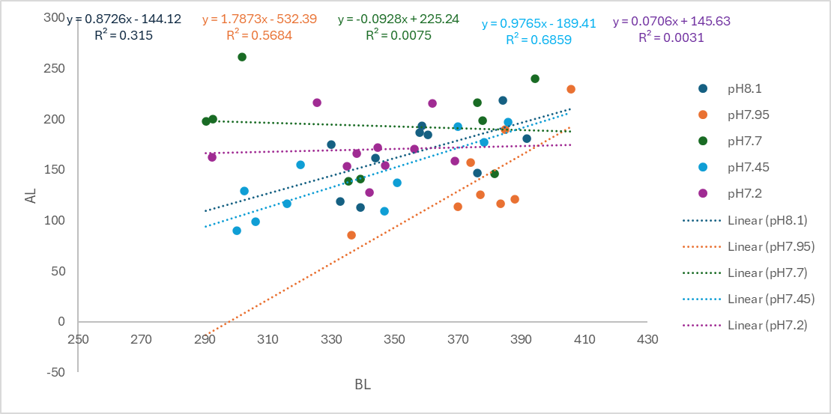
So I would not recommend this approach but here is another option:

- As you have two data for each larvae, only keep the biggest one
AL=Max(AL1, AL2)

- Make a regression between BL and AL for the control (pH 8.1)
AL = 0.8726 x BL – 144.12

- Standardize all the AL using the data from this regression
St_{AL} = (AL – (-144.12)) / (BL x 0.8726)
Data in the control should then all be around 1

- You can plot again the stressor (I’ve used nominal pH out of laziness but you can use the measured values instead)
No effect for pH

- I checked for the same parameter for single temperature and lithium
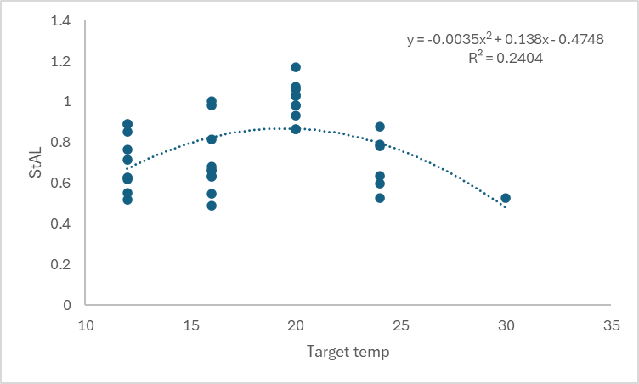
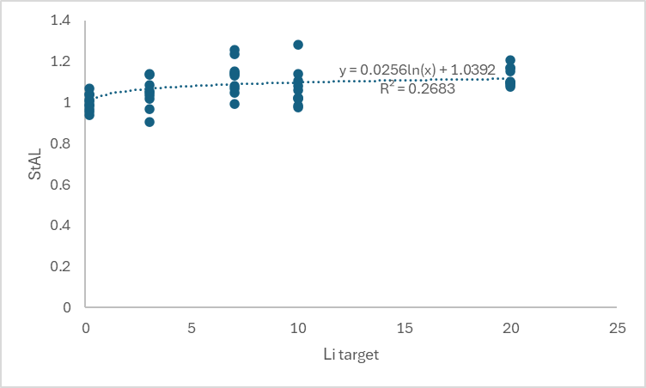
Changes in allometries for this arm say something about their energy status. They increase or decrease their relative arm length depending on the food availability and I think that energy is the cue (the direction depends on the species)
Addition from Einar. Feb 2nd 2026
Followed the same procedure, re-doing the graphs with the POR and BR standardized using the same regression approach. For temperature, pH and lithium.

Temperature POR and BR

Some effect of temperature. POR shows similar amount of change as AL. BR is inversed and has a stronger R2.

PH POR and BR

No effect of pH.

Lithium POR and BR

Maybe some effect in POR at highest level? BR does not show an effect.

